R.PRANUSHA

192111023

CSA1557-CLOUD COMPUTING

13)Create a Virtual Hard Disk and allocate the storage using VM ware Workstation

STEP 1:

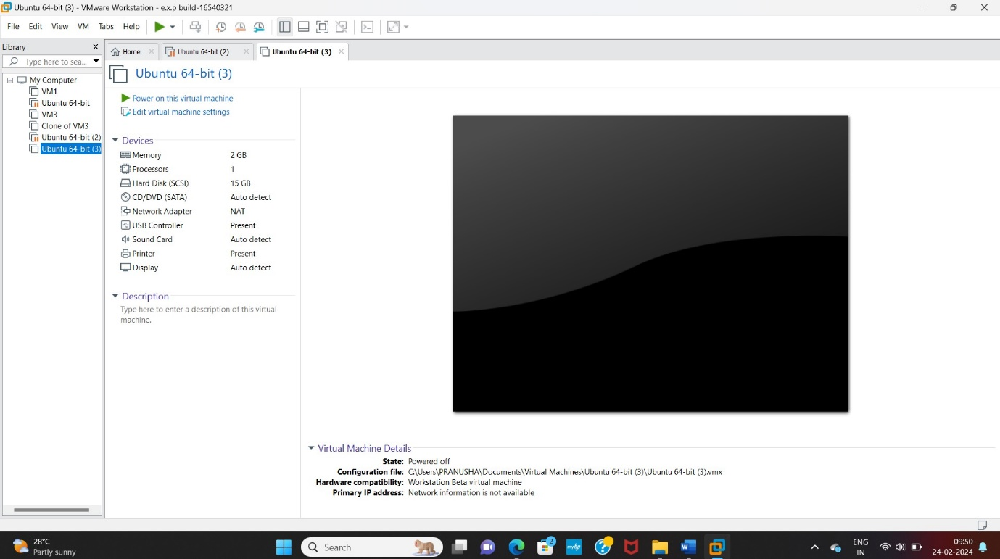

STEP 2:Click add option

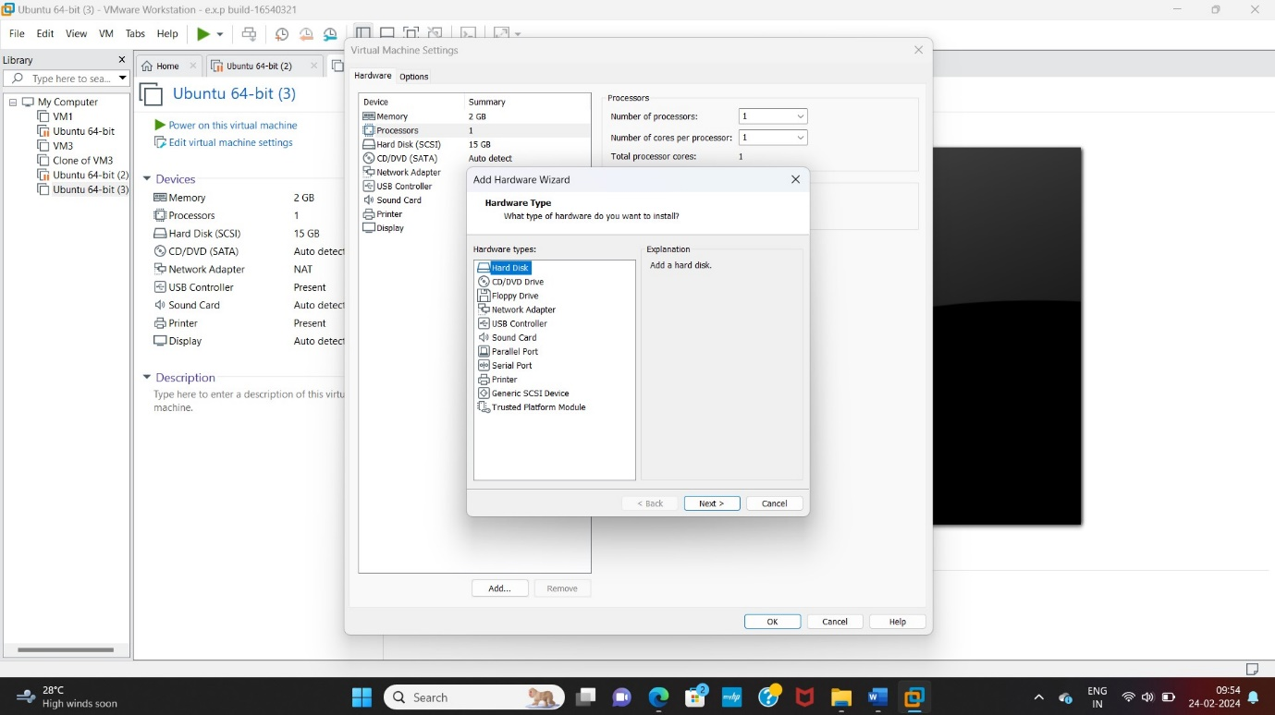

STEP 3: Create new virtual disk

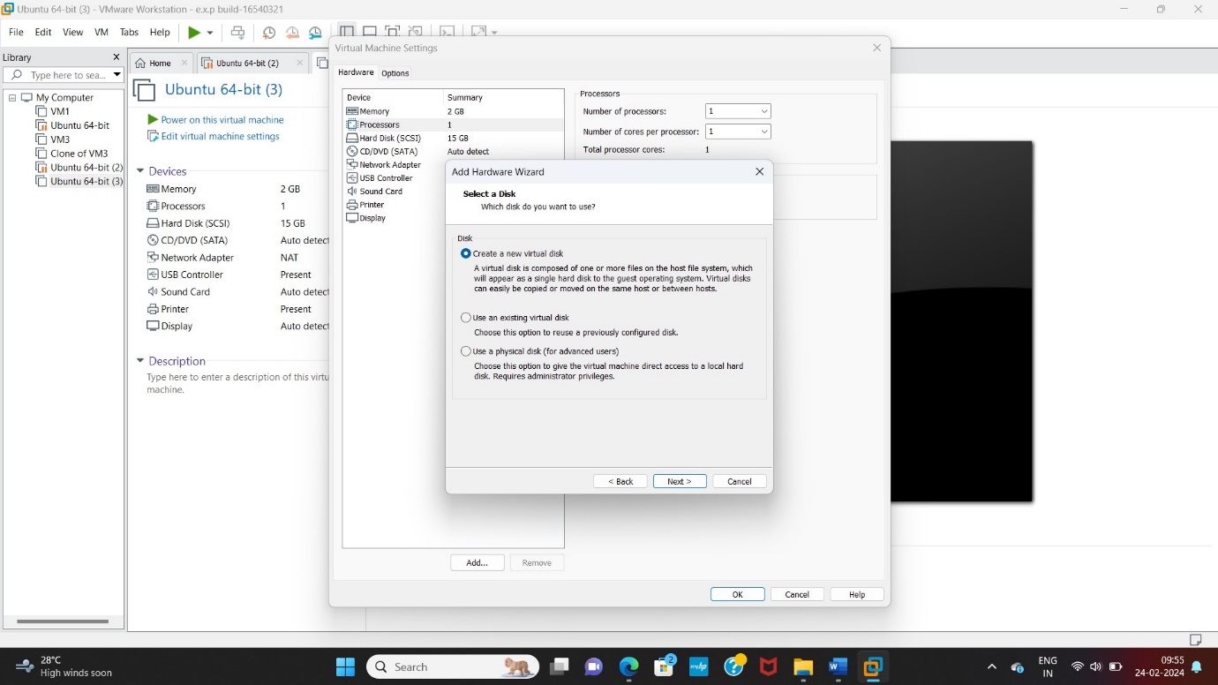

STEP 4:Store virtual disk in single file

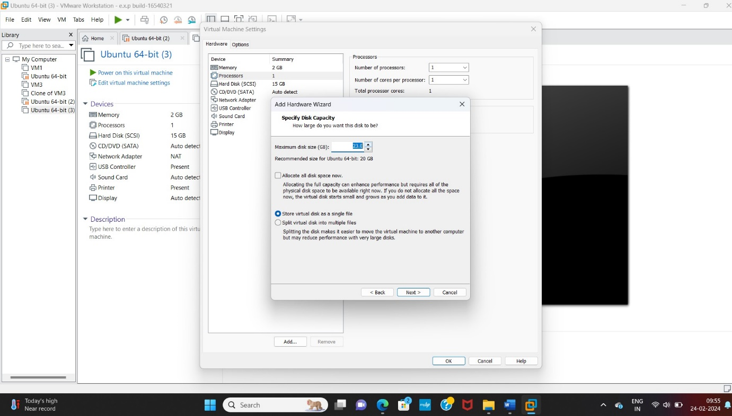

STEP 5:Name the new hard disk

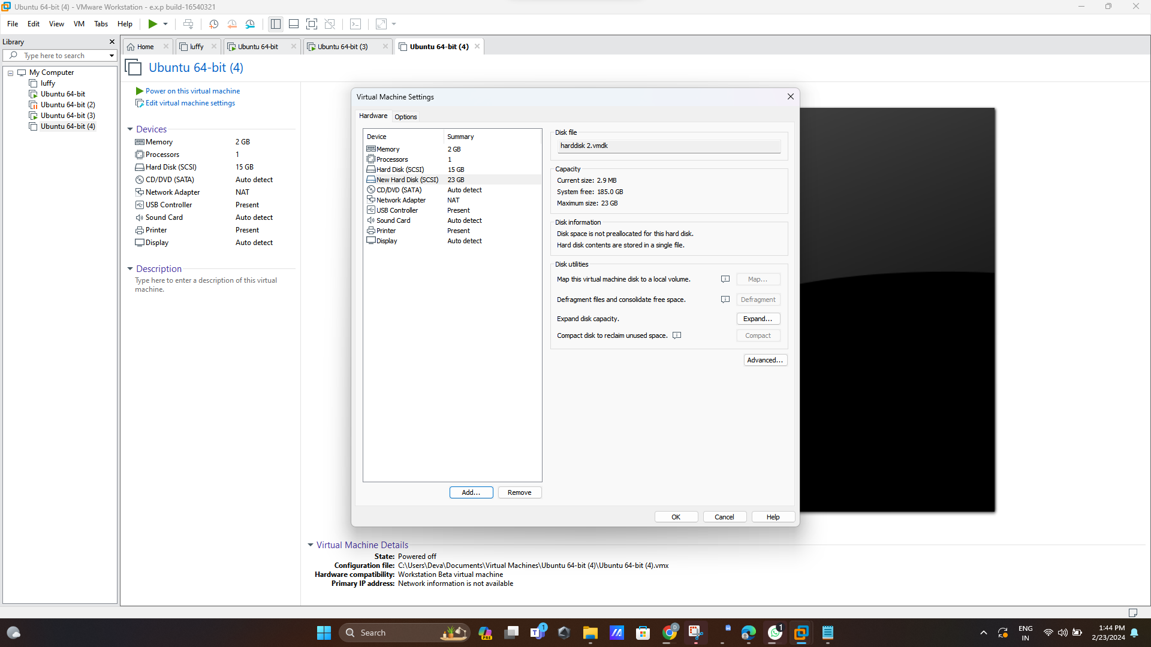

STEP 6: new hard disk created

